**PHASE 5**

**LESSON 5**

**PRACTICE ASSISTED 3**

**WEB HOSTING**

**CREATING INSTANCE:**

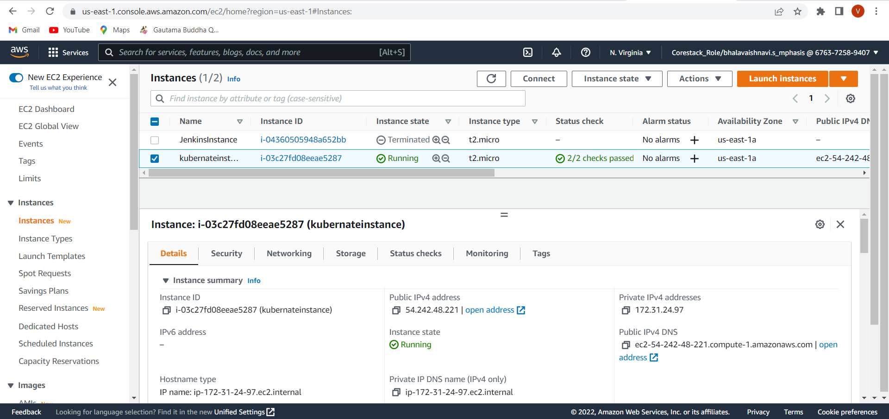

**SETUP ENVIRONMENT:**

